**Watch tower.**

This is the defensive structure in your base that will warn you of incoming attacks. It can only be built in your main base.

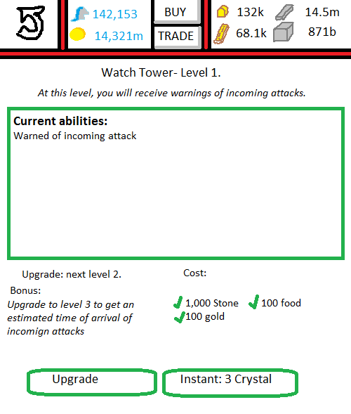

**User Interface: Main Base.**Selecting the watch tower opens a mini-menu. 2 options are given:  
 1. Go to watch tower.  
 2. Upgrade.

**User Interface: Watch tower.**There are no special functions that exist with this building.  
‘Upgrade’ will be ghosted if you do not have the correct resources. If you do, and you click it, your building will go into the building queue.   
‘Instant: 3 crystal’ will instantly upgrade your watch tower to level 2, without a build queue, and will deduct 3 crystal from your balance.

**Graphics in use:**GIMB_035. (1) Wall. Graphic of watch tower from level 1 to 4.  
GIMB_036. (2) Wall. Graphic of watch tower from level 5 to 9.  
GIMB_037. (3) Wall. Graphic of watch tower from levels 10+.

**Variables in use:**VS_WT1. The variable that holds the level of your watch tower.